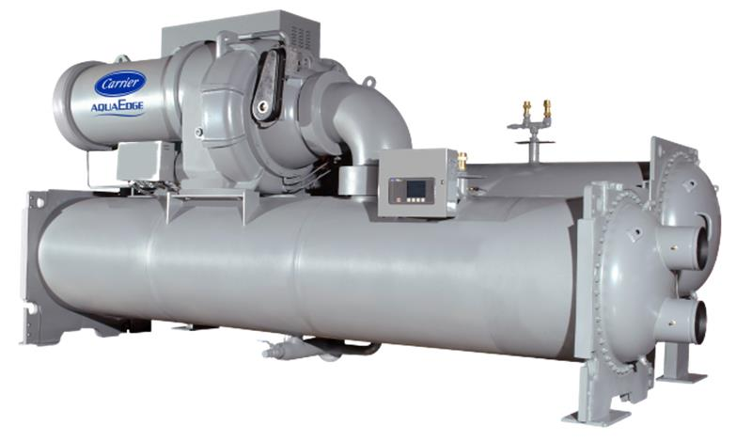

Chiller background
Chiller details | Information
Chiller Number | $ChillerSN
Location | $LocationName
City | $LocationCity
Year of Manufacturing (Age) | $Year_Age
Model Number | $ModelNum
Chiller Run Hours | $runhrs
Report Duration | $StartDate ~ $EndDate
Chiller Capacity (RT) | $DesignRT
Rated Chilled Water (kW) | 468
Design Leaving Chilled Water Temperature (º$T_Unit) | $Design_LCW
Design Entering Condenser Water Temperature (º$T_Unit) | $Design_ECDW

Summary
As part of Carrier's connected service program, our command center experts continuously monitor the performance and health of the chiller and its major components.

The chiller with serial number $ChillerSN underwent a chiller replacement analytics program considering its age and run hours are $Age years and $runhrs, respectively. Further analysis was conducted using real-time data from $StartDate to $EndDate.
The chiller's design full load efficiency is $Design_Efficiency kW/RT, while the computed chiller $performance_str is $maxium_data_efficiency $performance_unit at entering condenser water temperature (ECWT) of $maxium_data_min_ECDW-$maxium_data_max_ECDW º$T_Unit and an average leaving chilled water temperature (LCHWT) of $maxium_data_mean_LCW ºF during this period.

Chiller Performance Analysis
$effi_PLC_ECDW
Comments
- The chiller $performance_str($performance_unit) is steadily $trend compared to the previous year, indicating an increase in energy consumption per unit of cooling output.
- This trend indicates a potential decline in efficiency, emphasizing the need for further investigation to address and rectify underlying issues.

$Chiller efficiency vs %RLA vs Runhrs
Comments
- This plot illustrates various part-load efficiencies based on specific criteria:
  - The chiller operates at full load for more than 80% of the time: $full_load_80
  - The chiller frequently operates at less than 60% of its RLA for most of the time (more than 80% of the time): $low_load_80

$Chiller efficiency vs Cooling load vs Runhrs
Comments
- This plot illustrates various part-load efficiencies at different Cooling Loads:
  - The chiller operates maximum in the range $Ton_range RT.

Chiller Alarm Analysis
$alarm_count

Comments
- The chiller device has total of $total_alarms alarms during this analysis timeframe.
- There have $exceed_15 instances of chiller device alarms exceeding 15 in the last 2 months.

Chiller Water Temperature Analysis
$LCW_SP

Comments
- The chilled water leaving temperature meets $setpoint_meet% the set point.
$Entering_Condenser_Water

Comments
- The average condenser water temperature falls within the range of $min_ECDW º$T_Unit to $max_ECDW º $T_Unit.

Source File
- $Hyperlink

